University of Southern Mississippi

The Ideal 21st Century Classroom

ITD 645: Computers in Education

Authored by:
Lauren DeLaune
Kelly Hudson
Lindsey Jones
Rachel Long
6/28/20
Rachel Long ITD 645 6/28/20
Executive Summary
The purpose of this grant submission is to request $20,000 towards classroom technologies, furniture, and equipment to create the ideal classroom for diverse learners. Having a space where 21st century technology is present will enable student creativity, innovation, and success, and assist in teacher execution. Included in our submission, you will find our detailed budget, our classroom design, and a sample lesson utilizing our newly proposed technologies.
Our ideal 21st century classroom will be innovative and adaptable for all learners. It will be a safe space for introverts, a welcoming space for extroverts, a resourceful space for students with learning disabilities, and a space where all students will succeed. Research suggests that students are more successful when they feel they have ample resources to reach their academic goals. This grant would allow our classroom to be the supportive and resourceful environment that our students deserve.
If chosen for this grant, we will use the funds to develop a fully functional 21st century classroom. In doing so, we are implementing alternative options for traditional desks, outdated computers and printers, inadequate teacher resources, and scarce technology. After extensive research and budget meetings, we have developed the following list of replacement items necessary to fulfil our ideal 21st century classroom, as well as incorporating current classroom resources and free classroom software to stay within budget.
- Personal laptops for all 28 students
- Smart board – interactive white board
- Longue seating and coffee table for reading, quiet time, or group work
- A sitting/standing desktop riser to replace the teacher’s traditional, sitting desk
- Dry-erase work tables for adaptability
- Active learning stools to replace traditional desk chairs
- 1 additional bookshelf
- Larger and more advanced printer to accommodate all 28 students and the teacher
- Charging stations
- Various apps for diverse and disabled learners

In conclusion, we feel that by integrating these technologies and upgrades in our classroom, we will provide the ultimate learning space for a variety of learners. Our 21st century classroom will provide our students with the resources necessary to succeed not only in high school, but also prepare them for college and their future careers. Our vision cannot come to fruition without the assistance this grant is offering, which is why we are hopeful in our efforts, and look forward to providing our students with the best 21st century classroom we possibly can.
Purchases and Justifications
Item & Amount | Price | Source |  | Justification
Furniture
Lounge Seating (2)  Corwin Convertible Sleeper | $305.98  $152.99/unit | Wayfair  https://www.wayfair.com/furniture/pdp/serta-corwin-convertible-sleeper-xs10244.html |  | Provides students with a comfortable and relaxing environment to learn in, leading to higher attention rates.
Standing Desk (1)  Sit/Stand Desktop Riser H-7030 | $379 | ULINE  https://www.uline.com/BL_1894/Sit-Stand-Desktop-Risers?keywords=standing+desk |  | Can be attached to teacher’s existing desk. An adjustable-height standing desk will allow the teacher flexibility as well as comfort.
Work Tables (2)  Dry Erase Creator Table - Rectangle by Mooreco, 16X3QX-MRKR - Stock #20G12 | $599.90  ($299.95/unit) | Worthington Direct  https://www.worthingtondirect.com/desks/1633q1-mrkr-dry-erase-creator-table-rectangle.htm |  | Dry erase top tables are practical and durable, while being fun and inspiring student creativity. These table are perfect for creating large, real-time diagrams and concept maps.
Coffee Table  Davisson Coffee Table with Storage | $56.99 | Wayfair  https://www.wayfair.com/furniture/pdp/ebern-designs-davisson-coffee-table-with-storage-w000566505.html |  | A coffee table between the two futons will provide students a workspace in that area. This will turn the area from being a ‘lounge area’ into a productive but comfortable work space.
Desk Seating (28)  Active Learning Stool (20" H) | $1956.64  ($69.88/unit) | School Outfitters  https://www.schooloutfitters.com/catalog/product_info/pfam_id/PFAM53242/products_id/PRO68072 |  | Active learning stools allow students to move about while remaining in their seats. This can help students by giving them an outlet for their physical energy, allowing them to focus their mental energy on the task of learning.
Bookshelf (1)  6-Shelf Bookcase  H-7689 | $276 | ULINE  https://www.uline.com/BL_3941/Bookcases?keywords=bookshelf |  | This will double the amount of storage in the classroom, providing a space for additional reading materials and for laptop storage.
Technology
Laptops & Keyboards (28)  Surface Go 2 - Wi-Fi, Intel Pentium 4425Y, 4GB, 64GB  +  Surface Go Type Cover | $13,159.44  $469.98/unit  (laptop + keyboard) | Microsoft  https://www.microsoft.com/en-us/education/devices?&ef_id=Cj0KCQjwudb3BRC9ARIsAEa-vUtWBlZl6hwrirUdxP59c_BbBPM14ujLtNZB_eHHW8JDuSmhylc8q_QaAjDfEALw_wcB:G:s&OCID=AID2000043_SEM_:G:s&utm_source=google&gclid=Cj0KCQjwudb3BRC9ARIsAEa-vUtWBlZl6hwrirUdxP59c_BbBPM14ujLtNZB_eHHW8JDuSmhylc8q_QaAjDfEALw_wcB |  | Currently, the classroom houses four outdated computers for approximately 28 students. By replacing those computers with laptops for each student, we increase flexibility by giving students the ability to move between learning areas; we create a more equitable learning environment by giving all students access to the same technology; and we provide opportunities for technology to be more fully integrated into the curriculum.
Printer (1)  INKvestment Tank Color Inkjet All-in-One Printer with Up to 1-Year of Ink In-box | $279.99 | Brother USA  https://www.brother-usa.com/products/mfcj6545dw |  | The addition of a printer will double the printing capacity of the classroom. This particular printer will allow the teacher to print on a larger scale, enabling her to produce dynamic and informative diagrams and images.
Charging Stations (2)  S9 Power Floor Stand | $910  $455/unit | Chargetech  https://chargetech.com/product/s9-power-floor-stand-plus-branding/ |  | Charging stations will be needed to accommodate the new student laptops. These will allow students to use their devices for class work without the interruption of a dead battery.
Smart Board (1)  SMARTBOARD SBM680V Interactive Whiteboard | $1959.02 | Touchboards  https://www.touchboards.com/SMARTBOARD/SBM680V/?b=y&v=7922 |  | The addition of a Smart Board interactive white board will enable the teacher to create interactive presentations, increase active learning, and integrate technology more fully into the classroom setting. Adding a Smart Board will also double the learning space of the classroom, as the current white board will still be in use for more casual learning experiences.
Software and Apps
Nearpod | Free | https://nearpod.com/signup/ |  | Nearpod is an instructional platform that merges formative assessment and dynamic media for collaborative learning experiences. This software will allow the teacher to increase engagement and performance on formative assessments.
Calibre | Free | https://calibre-ebook.com/ |  | Calibre provides e-book management for students and teachers. With the addition of student laptops, the teacher will be able to assign more online readings. Calibre will provide a means of organizing, storing, and sharing those resources.
Blender | Free | https://www.blender.org/ |  | Blender is a 3D drawing and animation program. This tool will enhance students’ ability to create innovative designs.
LibreOffice | Free | https://www.libreoffice.org/ |  | An excellent, no-cost replacement for Microsoft Office. The program includes high-quality word processing, spreadsheet, presentation, drawing and equation editing tools. This will provide a free alternative for students who cannot afford their own version of Office.
Dictation Software  Co:Writer Universal | $59.88/1 year  $4.99/month | https://learningtools.donjohnston.com/product/cowriter/ |  | Co:Writer Universal uses grammar-smart and vocabulary-smart word prediction, translation support, and speech recognition software. This tool will help support students who have trouble writing, especially students will physical disabilities that prevent them from writing.
SoundingBoard | Free | https://www.ablenetinc.com/soundingboard |  | SoundingBoard is a free mobile augmentative and alternative communication (AAC) app designed for children who are unable to speak (or who have limited speech) to help them communicate. In order to meet the needs of this particular population, the app comes with preloaded boards using symbols with recorded messages. Students select and press images on the board to prompt a verbal message. This toll will ensure that students of all abilities feel welcomed and supported in the classroom.
Seeing AI | Free | https://apps.apple.com/us/app/id999062298?ign-mpt=uo%3D4 |  | This free app uses AI to communicate the world to visually impaired people. This tool will help visually impaired students feel more at home and capable in the classroom.
OpenDyslexic Font | Free | https://opendyslexic.org/ |  | This open source font was created to increase readability for readers with dyslexia. It is free for commercial and personal use. This simple solution has the potential to make dyslexic students feel more comfortable with reading and writing. For the student, this could mean an increased sense of capability and determination.
NVDA Screen Reader | Free | https://www.nvaccess.org/ |  | · NonVisual Desktop Access (NVDA) is an open source screen reader that allows users who are blind or have low vison to access computers running Windows. It has the ability to run entirely from USB drive with no installation, saving space on the students’ laptops. This tool will enable students with visual impairments to interact with online content.
Notability | $8.99 | https://www.gingerlabs.com/ |  | Notability allows students of all abilities to create, share, and manage notes using handwriting, typing, audio recordings, and photos. This tool will allow students with physical disabilities to take effective and descriptive notes in class using the method that works best for them.
Total Cost: |  |  | $19,951.83

Classroom Design & Possible Configurations
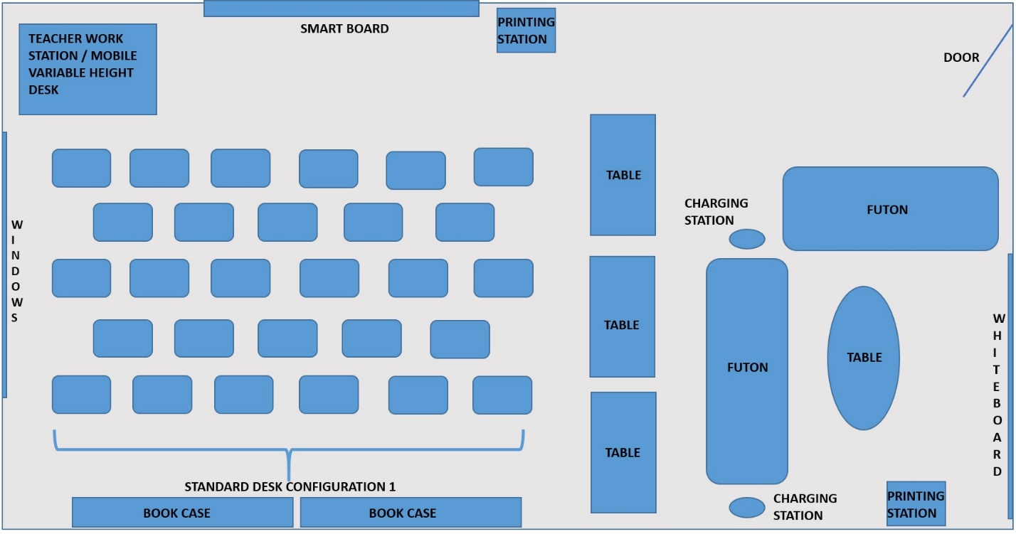
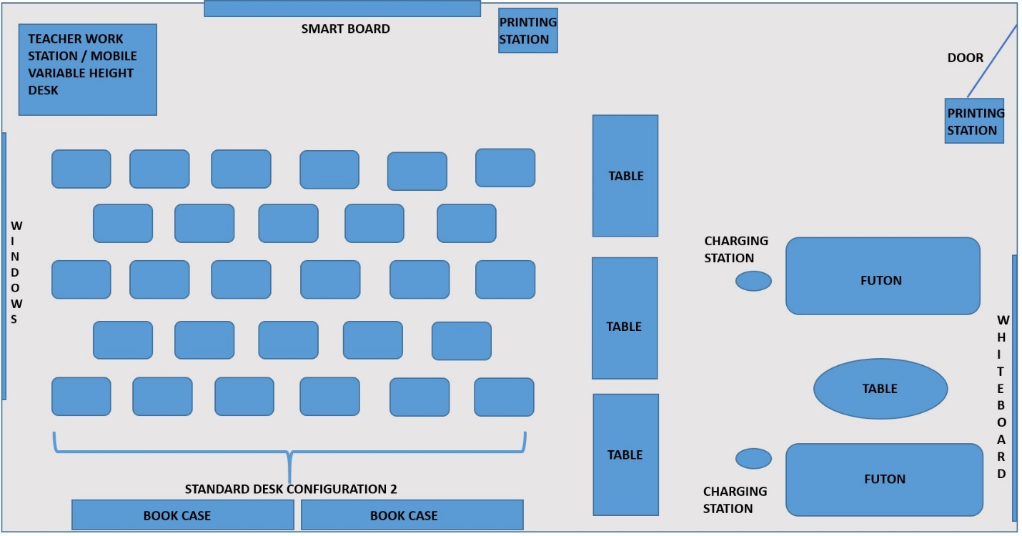
Figures 1-2
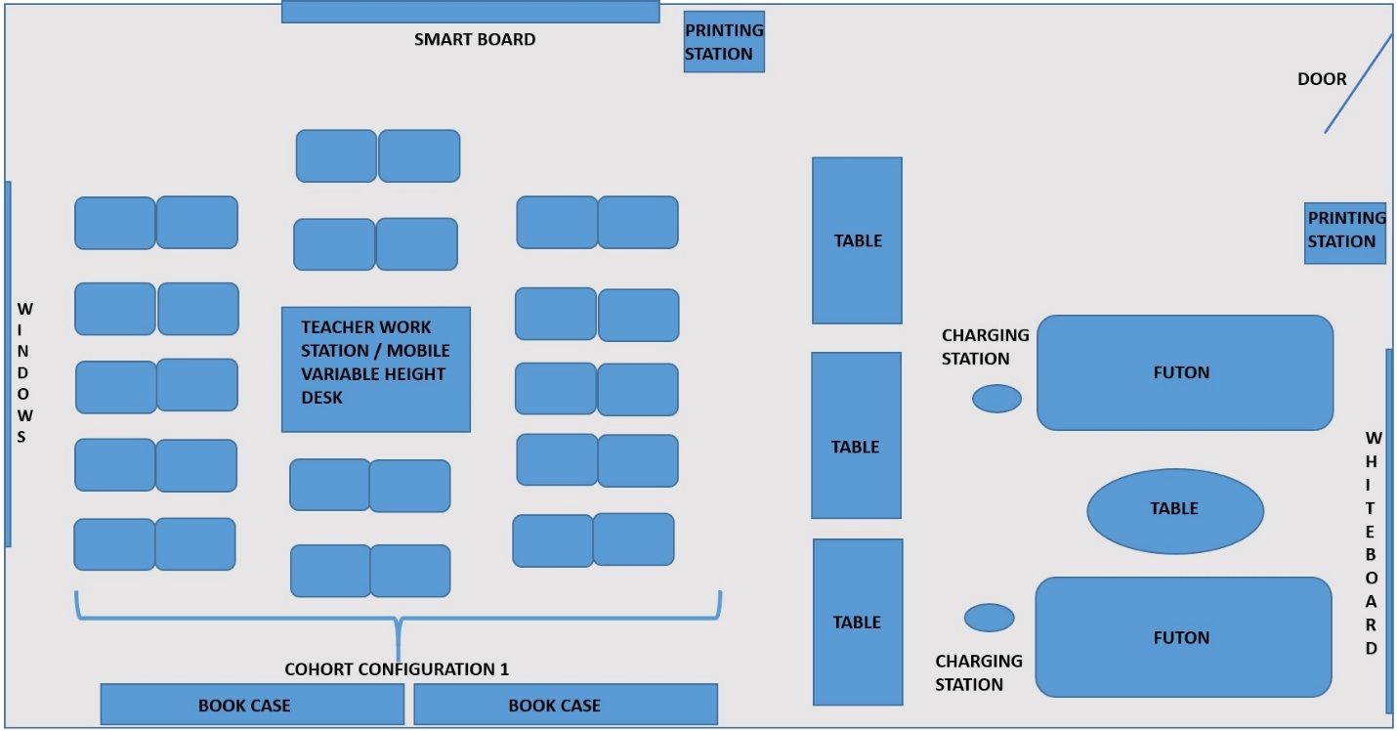
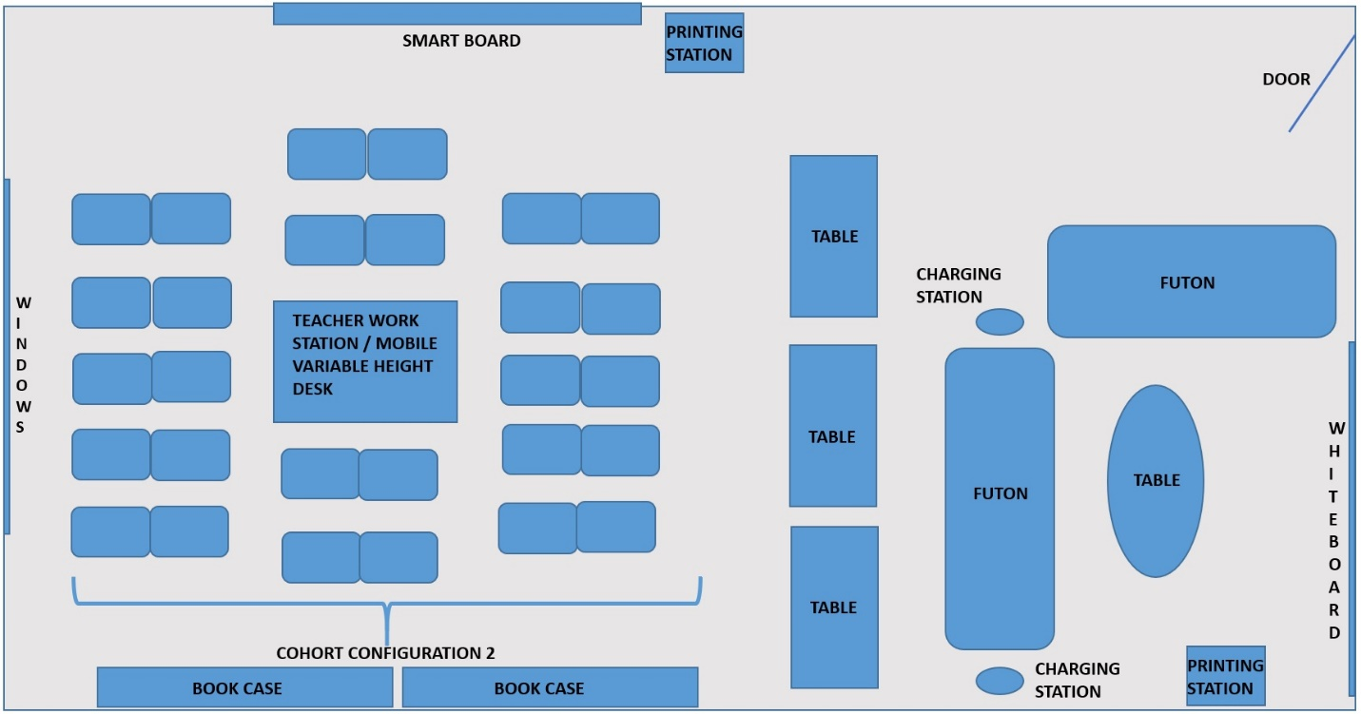
Figures 3-4
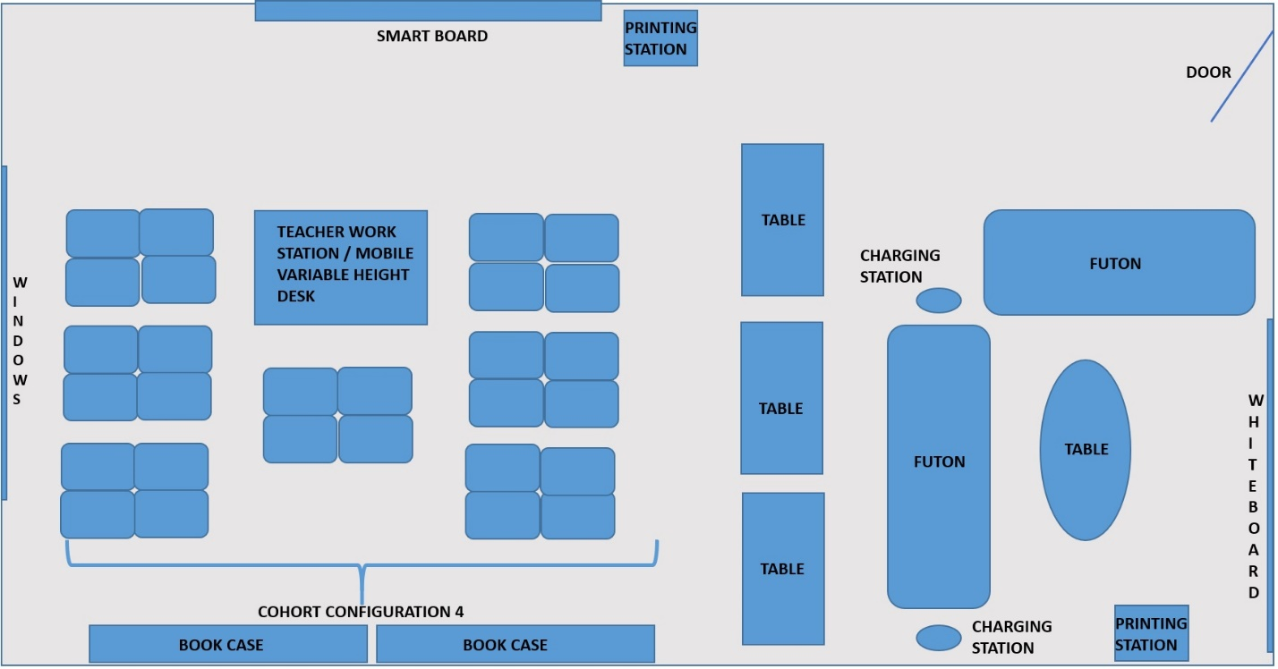
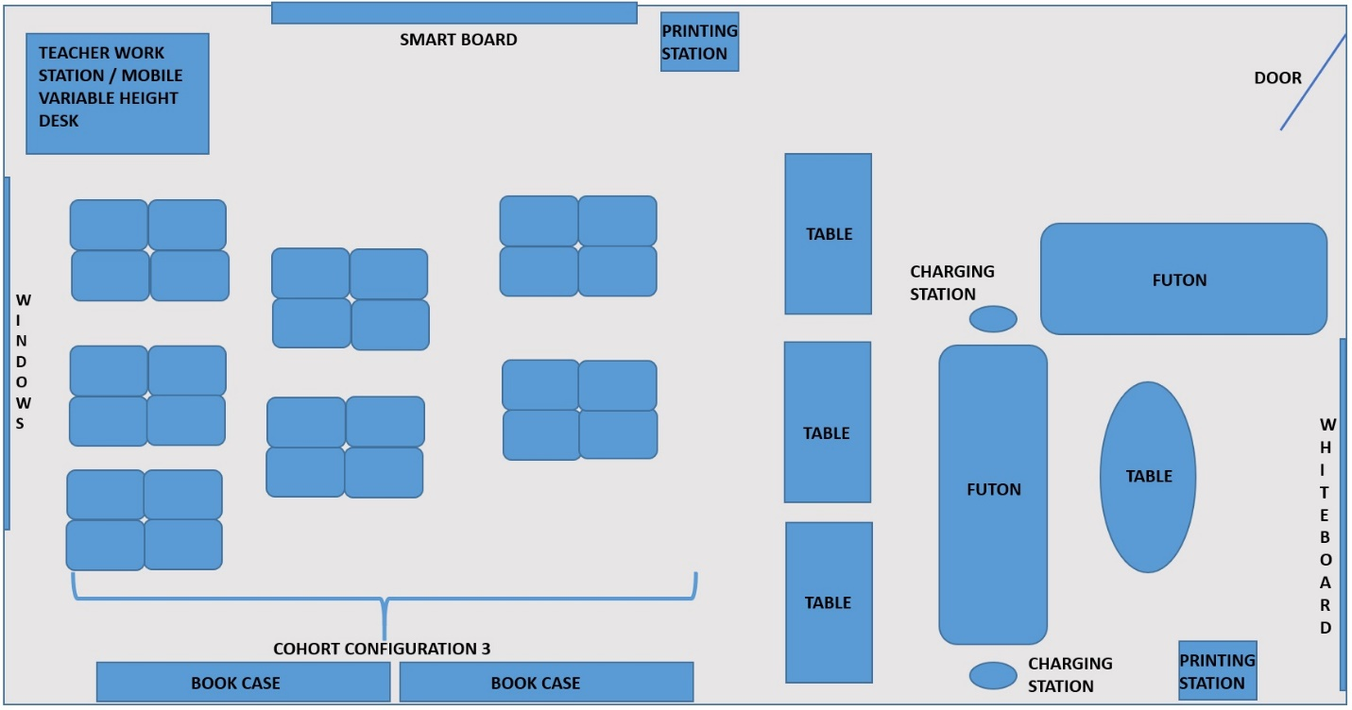
Figures 5-6
Sample Lesson

Grade Level and Subject: 7th grade Science Unit: From Molecules to Organisms: Structure and Processes
Instructional Unit Design using the Dynamic Instructional Design (DID) Model
- Student Demographics
  - Number of students: 28
  - Gender make-up: 18 males and 10 females
  - Ethnic make-up: African American, Caucasian, Hispanic and Asian
  - Learning styles/Multiple intelligences listed in order of prevalence: Visual, Kinesthetic, Verbal, Logical, Auditory/Musical, Interpersonal, Intrapersonal, Naturalistic
  - Skills students bring into the classroom: Engaging in arguments from scientific evidence skills were taught in K-6. Students will have knowledge of how to use evidence from observations and research to construct an argument to support a claim.
- Unit Objectives
  - MS-LSI-1: Conduct an investigation to provide evidence that living things are made of cells; either on cell or many different number and types of cells.
    - The student will be able to support a claim that cells are the building blocks of living things by providing evidence from a variety of sources with 75 percent accuracy.
- Teaching and Learning Strategies
  - Teaching Strategies
    - Direct Instruction: Teacher will use a presentation that includes visuals describe the characteristics of living things. Teacher will then show a video that describes the differences between living, nonliving and once living things.
    - Informal assessment:
      - The teacher will show images of objects that students will classify as living, nonliving or once living.
      - The teacher will observe students during peer-to-peer collaborations and informally questions students to redirect the group when necessary.
  - Learning Strategies
    - Concept exploration: Students will work with a partner to classify a group of objects as living vs. nonliving and reflect on the characteristics of living and nonliving things. Students will be provided with web-based sources to use for evidence.
    - Inquiry-based concept reinforcement: Students will work in small groups. Students will ignite a candle and observe it for several minutes. They will record all observations and conclusions in a laboratory notebook. The students will use their observations and research to classify the flame as living, nonliving or once living.
    - Summative Assessment (Exit Evaluation): The student will write a short paragraph that describes how they would explain to a kindergartener what makes living things “alive.”
- Technology Resources
  - Student laptops, smartboard, dry erase tables, printer, charging stations, software: Nearpod, Calibre, Blender, LibreOffice, Dictation Software, SoundingBoard, Seeing AI, OpenDyslexic Font, NVDA Screen Reader, Notability
- Assessment and revision plan
  - Students will be graded upon the outcome of their exit evaluation. Students should be able to list 6 out of the 8 characteristics of living things in their explanation to a kindergartener. If less than 50% of the class does not meet this benchmark, the teacher will remediate during the following class period. Remediation will include having students sort handheld objects into plastic Tupperware containers.
Example Lesson/Action Plan
Subject: 7th Grade Science | Standards: MS-LS1-1, RL.6.1, W.6.1
Unit: From Molecules to Organisms: Structure and Processes | Lesson: Cells: Building block of living things
Ready the Learner | Objective(s)
Warm-up using Nearpod to assess student’s prior knowledge:  - Show students pictures of three objects: car being manufactured, Lego figure, and puzzle  1. What do these pictures have in common?  2. Are these things living or non-living? How do you know?  3. What do you think living things are made up of? | - The student will be able to sort living and non-living things using the Cell Theory into a list with 100 percent accuracy.  - The student will be able to support a claim that cells are the building blocks of living things by providing evidence from a variety of sources with 75 percent accuracy.
Prepare the Lesson
Prepare the Classroom
- Group student desks into groups of four
- Ensure smartboard, printers and charging stations are on and functioning properly
- Create Nearpod warmup and student digital worksheets
- Purchase tea candles and matches
- Check all internet links for viability, replace broken links with new content
Learning Plan
- Concept exploration: Students will collaborate in a group of 4 to complete the Living vs. Non-living digital worksheet. Teacher will provide web-based resources for students to research. Students will screen capture images to include in each classification. Each group will share their images via the smartboard. Students are encouraged to print their work to include in their lab notebook.
- Direct Instruction: Teacher will use a PowerPoint presentation to teach students the Cell Theory and the 8 characteristics of living things.
- Formative assessment: The teacher will show a short video with additional images and descriptions of living, nonliving and once living things. Students will take a formative assessment using the gamification feature on Nearpod to classify 15 objects as living, nonliving or once living.
- Inquiry-Based concept reinforcement: Students will complete a laboratory activity. The teachers will distribute two tea candles to each student group. One will be lit and the other will remain unlit. The group will make predictions, observations and final conclusions regarding how to classify the flame using the principles learned in class regarding living things. The teacher will use observation and informal inquiry to assess and redirect student groups.
- Summative assessment (Exit evaluation): Students will be presented with a scenario to explain to a kindergartener the 8 things that make living things “alive.” Students are given the option to write a paragraph or create a short video/audio clip to support their claim.
- Alternate lesson (depending on time): Students watch videos and observe images that support each part of the cell theory. Students reflect on several questions: How to cells make up an organism? What would happen to living things without cells? Where do new cells come from? Explain the terms multicellular and unicellular. Are bacteria alive? Why do you think this is?
- Extension assignment (for gifted students): For homework or with extra class time, gifted students will be assigned to research the following questions: What is a virus? Is a virus alive? Defend your conclusion using scientific reasoning and present evidence. The student will be provided with source materials.
Technology and Materials
- Student digital worksheets: Living vs. Nonliving Classification Sheet, Lab: Is a flame alive?, Exit Evaluation Scenario, Alternate lesson questionnaire, extension assignment
- 14 tea candles, box of matches, ruler
- Student laptops, smartboard, dry erase tables, printer, charging stations, software: Nearpod, Calibre, Blender, LibreOffice, Dictation Software, SoundingBoard, Seeing AI, OpenDyslexic Font, NVDA Screen Reader, Notability
Check for Success
- Exit evaluations are reviewed following class. Student answers should include 6 of the 8 supporting characteristics of living things. If less than 50% of the class (<14 students) hit this benchmark, then the teacher will remediate the following class period using a Venn diagram to compare living and nonliving things using the characteristics of life and the cell theory.
Accommodations
- ELL and dyslexic students will have multiple opportunities to edit their worksheets or provide their answers using alternative formats. Note-taking templates and dictation software make note-taking more organized and more efficient for these students. The digital format allows students to take these notes/worksheets home.
- Hearing and visually impaired students also benefit from dictation and other accommodating technologies to enhance note taking and in-class communications.
- Gifted students will be assigned the extension assignment for homework or as an in-class assignment.
- Student groups can utilize alternative seating options, whiteboards and dry erase tables to brainstorm or create concept maps as they discuss the various activities within the lesson.
Teacher Prompts
- Candle Laboratory:
  - Remind students of the difference between qualitative and quantitative observations.
  - Review fire safety procedures before lighting the candle.
    - Pull back long hair and adjust loose clothing. Do not dispose of hot materials in the trash can. Do not turn your back to the flame. Report any injuries to the teacher immediately.
- Ask students to discuss the types of cells that the human body is composed of. Lead into discussion of microscope being needed to see these different types of cells.

